Purchase Invoice Processing Solution and PBI
Author:- Keith Roberts
Date:- October 2026
Technical Architecture & Support Handover

Contents
Document Purpose 4
1. Solution Overview 4
2. High Level Architecture 5
3. End-to-End Invoice Lifecycle 6
Stage 1 - Invoice Receipt 6
Stage 2 - Invoice Capture 6
Stage 3 - Invoice Registration 7
Stage 4 - Invoice Coding 8
Stage 5 – Assistant and Approval Assignment 8
Stage 6 - Approval Notification 9
Stage 7 - Approver Review 9
Stage 8 - Workflow Decision 10
Stage 9 - Final Approval 10
Stage 10 - Finance Processing 10
Stage 11 – Ready for Export to CSV 11
Stage 12 - Completion 11
4. SharePoint Structure 11
5. Power App Design 14
6. Power Automate Design 14
8. Operational Support Requirements 17
9. Business Continuity 18
Technical Summary 19
Artifacts 20
PowerBI Reports 20
Power Apps Applications 20
Power Automate Flows 21
Purchase Invoice Processing 21
PowerBI semantic model 21
Share Point Lists 22
Lists not already detailed 22

Document Purpose
This document provides a technical overview of the Purchase Invoice Processing Solution, including architecture, data flows, application components, SharePoint structures, Power Automate workflows, security model, operational support requirements, and business continuity considerations.
The document is intended for IT Application Support, Infrastructure, M365 Administration, and future developers assuming ownership of the solution.

1. Solution Overview
The Purchase Invoice Processing Solution has been developed using Microsoft Power Platform technologies to manage the end-to-end lifecycle of supplier invoices from receipt through approval and submission to Finance.
The solution provides:
- Centralised invoice storage
- Workflow-driven approval routing
- Approval audit trail
- Automated notifications and reminders
- Budget-holder review capability
- Finance visibility of invoice status
- Complete processing history
The solution utilises:
- SharePoint Online
- Power Apps
- Power Automate
- Exchange Online
- Microsoft Entra ID

2. High Level Architecture
Supplier
│
▼
Shared Mailbox (or similar)
(finance@dec.org.uk)
│
▼
Power Automate
(New document Trigger)
Invoice Document Library
(SharePoint)
│
▼
Invoice Register and Coding Line lists
(SharePoint)
│
▼
Power App
(Review, workflow & Approval)
│
▼
Power Automate
(notification Engine)
│
▼
Approver Notifications
│
▼
Power App
Approval Decision
│
▼
Invoice Status Updated
│
▼
Finance Processing Queue
│
▼
SUN Financials
(Posting via QA DataSend)

3. End-to-End Invoice Lifecycle

Stage 1 - Invoice Receipt
A supplier sends an invoice to:
finance@dec.org.uk (or similar)
Document is saved to specific SharePoint department folder

Stage 2 - Invoice Capture
The invoice attachment is extracted by Power Automate.
The flow:
- Captures document metadata
- Links to PDF attachment
- Creates invoice record
- Initiates workflow processing
Output
Invoice PDF stored in:
SharePoint Document Library
Purchase Invoice Processing

Stage 3 - Invoice Registration
Power Automate creates a record in SharePoint.
SharePoint List
InvoiceRegister
Example fields:
InvoiceNumber
SupplierName
InvoiceDate
InvoiceValue
ReceivedDate
DocumentLink
Status
NextApprover
Comments
Initial Status
ReadyForCoding

Stage 4 - Invoice Coding
Finance staff access the Power App.
Users:
- Review invoice
- Review Cost centre
- Assign Supplier account code
- Enter Invoice and due dates
- Enter Amount(s)
- Add supporting comments
Power App
Purchase Invoice Processing App
SharePoint Update
Power App updates:
InvoiceRegister and InvoiceCodingLines
using Patch operations.

Stage 5 – Assistant and Approval Assignment
Once coding is complete:
Power App determines the assistant/approver based on:
- Department
- Approval Authority Matrix
Available actions:
Approve
Reject (to previous stage)
Query
Add coding lines
Status
Coded changed to ReadyForBH

Stage 6 - Approval Notification
Power Automate sends ‘Nudge’ e-mails for open queue items
Trigger
Scheduled (Mon/Wed/Thu 2PM)
Conditions:
Status = Coded/ReadyforBH/BHApproved/CEOApproved
Email contains:
- Invoice volume details
- Power App URL

Stage 7 - Approver Review
Approver accesses the Power App.
Available actions:
Approve
Reject (to previous stage)
Query
The approver can:
- View invoice PDF
- View coding
- View previous comments and cost distribution
- Add comments

Stage 8 - Workflow Decision
Approve
Status changes to:
BHApproved
Reject
Status changes to:
Rejected
Invoice returned to Budget Holder Assistant
Query
Status changes to:
Query Raised
Sent to original processors queue.

Stage 9 - Final Approval
Where multiple approval levels exist:
Power Apps routes to the next approver.
Status sequence:
Pending Approval
→ High/Low BH Approval
→ CEO Approval
→ Financial Director Approval

Stage 10 - Finance Processing
Once final approval has occurred:
Status: FDApproved
Invoice becomes visible to Finance processing review team.
Once reviewed status sequence
ReadyForExport

Stage 11 – Ready for Export to CSV
Status: ReadyForExport
Once Invoices are selected and exported
Status:- Exported
Finance then posts invoice into:
SharePoint CSV ready for final Finance review in SharePoint and posting to SUN Financials

Stage 12 - Completion
Status: Exported
Invoice workflow completes.
Full approval history remains stored within SharePoint.

4. SharePoint Structure
Document Library
Purchase Invoice Processing
Purpose: Stores supplier invoice PDFs in department folders.
Contents: Invoice PDFs

SharePoint Lists
InvoiceRegister
Primary workflow list.
Stores:
- Invoice Metadata
- Coding Information
- Approvers
- Workflow Status
- Document Link
- Processing Dates

InvoiceRegister
Stores audit events.
Examples:
- Invoice Submitted
- Invoice Approved
- Invoice Rejected
- Comment Added
- Status Changed

InvoiceCodingLines
Primary workflow list.
Stores:
- Invoice Register ID (Foreign key)
- Nominal Code
- Appeal Code
- Grant Code
- Restriction Code
- Line Amount
- Line number (sequence)

GrantCodes
Static data list.
Stores:
- Grant Code
- Description
- Active flag

NominalCodes
Static data list.
Stores:
- Nominal Code
- Description
- Active flag

Suppliers
Static data list.
Stores:
- Title (Supplier code)
- Supplier (Description)
- Status (Active)
- Supplier folder (Contracts/correspondence etc)
- Dept
- Key Supplier flag
- Contract Link
- Contract start date
- Contract end date
- Notes

ApprovalRouting
Primary user list.
Stores:
RoleKey
Department
Approver email

5. Power App Design
Application Role
The Power App provides the user interface.
Responsibilities
- Calculate approval routing
- Capture user actions
- Display invoice information
- Display approval history
- Maintain comments
- Update SharePoint records
Non-Responsibilities
The app does not:
- Consume the initial invoice data from the stored file (e.g. pdf)
- Generate notifications
- Create reminders
These activities are handled by Power Automate.

6. Power Automate Design
Workflow Engine
Power Automate contains workflow logic for ingestion, reminder emails, Export, URL definition.
This enables process changes without modifying the Power App.

Flow - Invoice Capture
Name - InvoiceApproval_SharePoint_List - Upload
Trigger
When a new document is added to the document library
Actions:
Save PDF
Create InvoiceRegister list record and first InvoiceCodingLine
Assign status = ReadyForCoding

Flow - Get URL for PDFViewer
Name - GetPDFDataURI
Trigger
PDF Viewer in galleries
Action:-
Derive URL from fileidentifier field in the InvoiceRegister and return to PowerApps

Flow - Reminder Process
Name - PIR - Nudge e-mails
Trigger
Recurring Schedule
Frequency:
Daily (Mon/Wed/Fri) 2PM
Actions:
Find outstanding approvals
Send reminders of outstanding items in processing queues
Log notification (Flow history)

Flow - Export CSV journal of invoices
Name - ExportSUN
Trigger
Manual selection of invoices to export at Finance Review stage
Actions:
Extract invoice headers and coding lines from selected invoices in the SharePoint lists InvoiceRegister and InvoiceCodingLines
Assign status = Exported
Assign BatchID:- SUN-yyyymmdd-hhmmss
Assign ExportedDate:- utcNow
Assign PaymentStastus:- Not Paid
7. Security Model
Authentication
Authentication provided through:
Microsoft Entra ID
No application-specific accounts exist.

Permissions
Finance Team
Full Access
Budget Holder Assistant
Amend and Approval Access
Budget Holders
Amend and Approval Access
CEO
Approval Access
Financial Director
Approval Access
IT Support
Owner Access
Developers
Non-Production Only (Eventually!)

8. Operational Support Requirements
SharePoint
Responsible Team:
M365 Support (TBC)
Tasks:
- Permission management
- List maintenance
- Document recovery
- Storage monitoring

Power Apps
Responsible Team:
Applications Team (TBC)
Tasks:
- Version management
- UI changes
- Connector maintenance

Power Automate
Responsible Team:
Applications Team (TBC)
Tasks:
- Failed run monitoring
- Workflow maintenance
- Connection management
- Notification maintenance

9. Business Continuity
To minimise key-person dependency:
Shared Mailbox
finance@dec.org.uk
should be used for all workflow notifications. (Outstanding setup – IT owner of the service account needs to do this)
Ownership
At least two individuals should be configured as:
- Power App Owners
- Flow Owners
- SharePoint Site Owners
Backup
Export and retain:
- Power App package
- Flow definitions
- SharePoint schema documentation
- Approval matrix configuration

Technical Summary
The Purchase Invoice Processing Solution is designed around a central SharePoint-based workflow architecture. SharePoint acts as the system of record, Power Apps provides the user interface and workflow engine, and Power Automate acts as the Invoice intake and e-mail engine. Invoice documents and workflow data are stored within SharePoint, while all approval routing, notifications, reminders, and escalations are managed by PowerApps and Power Automate. This separation of responsibilities simplifies support, improves maintainability, and allows workflow changes to be implemented with minimal impact on the user interface.

Artifacts

PowerBI Reports
- DEC – MAC – ALL.pbix
Purpose:- Report Management Accounts and capture commentary and budgets
- Finance Budget Tracker.pbix
Purpose:- Track, report and update Fundraising Actuals and budgets
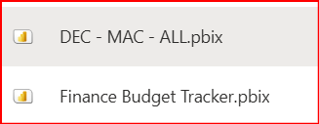

Power Apps Applications
Purchase Invoice Processing
- Purchase Invoice Coding and Approval – Desktop copy
Purpose:- Purchase Invoice processing system end-to-end
- DEC_MAC_Edit_Commentary
Purpose:- Capture commentary against the DEC MAC report
- Finance Budget Tracker
Purpose:- Capture user input against Finance Budget Tracker report
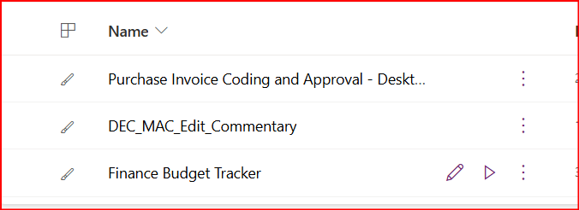

Power Automate Flows

Purchase Invoice Processing
- InvoiceApproval_SharePoint_List – Upload
Purpose:- Adds record to InvoiceRegister List once file is placed in the directory
- PIR – Nudge e-mails
Purpose:- Sends scheduled emails to invoice processors of queue status
- GetPDFDataURl
Purpose:- Derive a suitable link used to display the invoice in the image viewer
- ExportSun
Purpose:- Create a csv file for subsequent import into SunSystems Financials

PowerBI semantic model
- Refresh Power BI after Q&A extract
Purpose:- Update the Semantic model with fresh data
- Finance Budget Tracker
Purpose:- Update the Semantic model from list Fundraising_Projections
- PA_Refresh_Dataset_After_Comment
Purpose:- Update the Semantic model from list DeptAccountCommentary

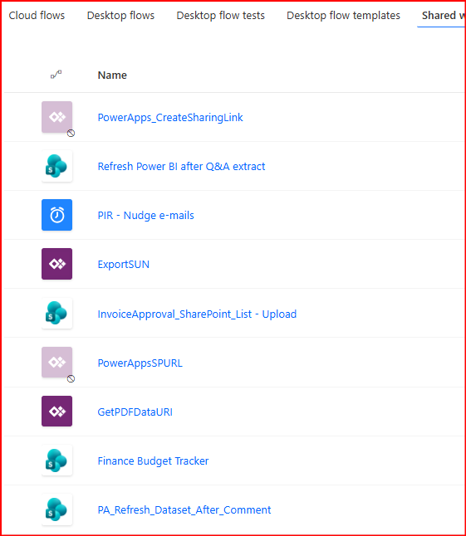

Share Point Lists

Lists not already detailed
DeptAccountCommentary
User input Data capture list.
Stores:
- Department
- Account code
- Appeal Code
- Comment
- Date modified
- Modified by
- Trigger Refresh flag
- Composite key
Fundraising_Projections
User input Data capture list.
Stores
- Account Code
- Expected Projection
- Commentary
- Dept
- Appeal
- Last updated by
Staff_Master - Purpose:- Unknown (Out of scope)
